**BOOTSTRAP**

In bootstrap there are Breakpoint, Container, Row and columns  
  
**Bootstrap Grid system**   
  
**Breakpoint**

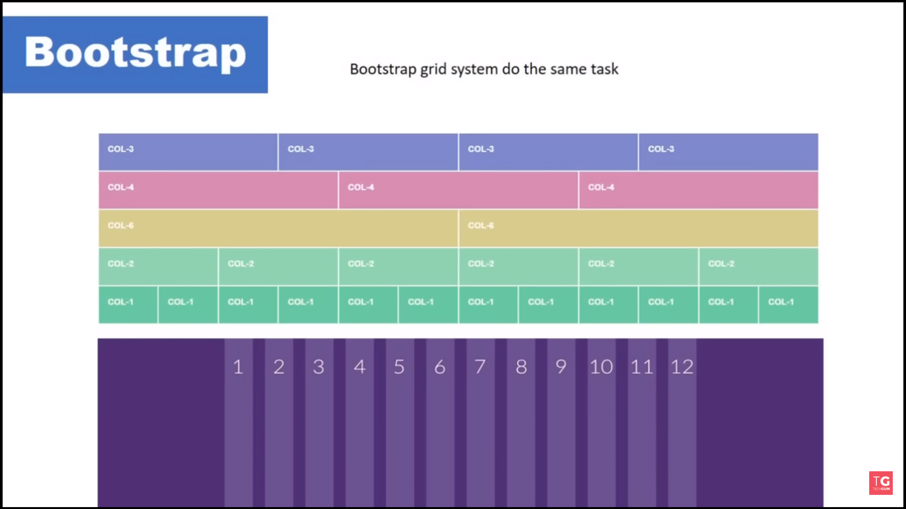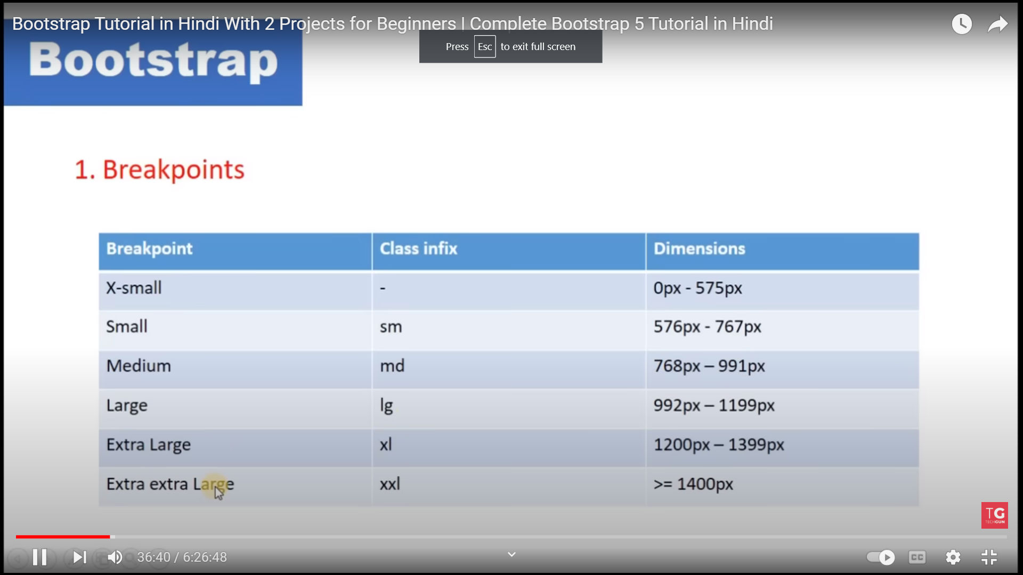

**Container**in a webpage everything is wrapup in a container let suppose the screen size is 100% and if you want you can make website in 80% screen and that page is containing in a container   
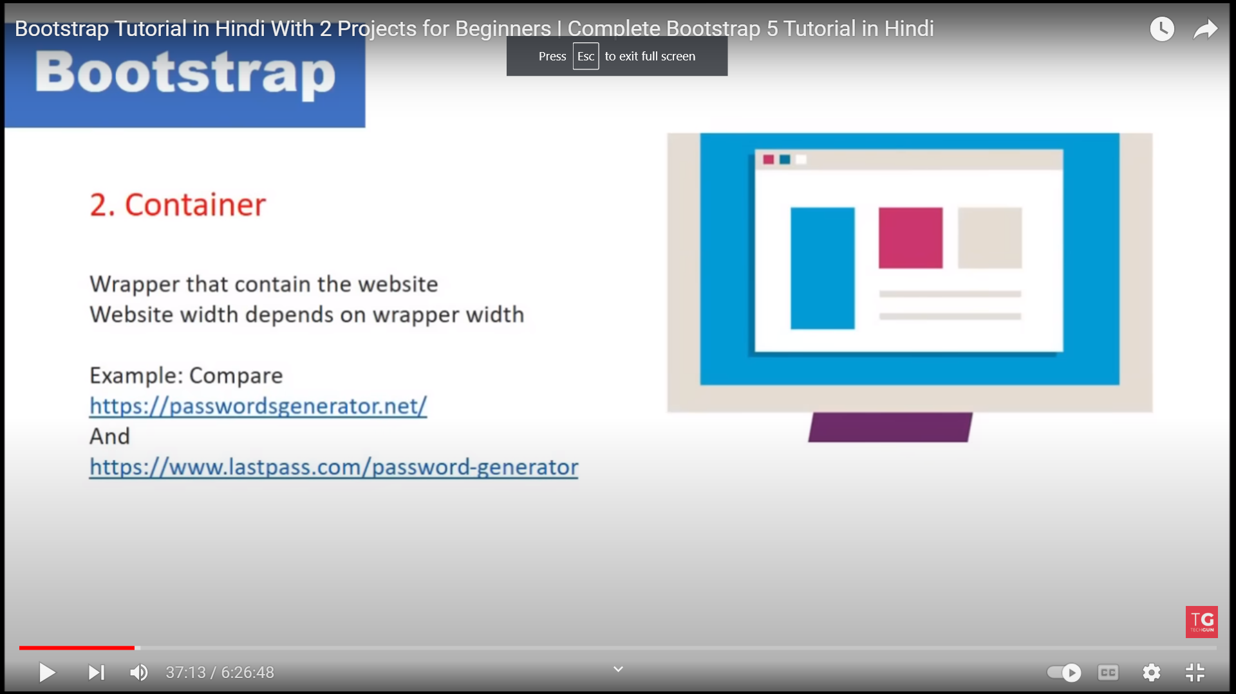  
**Rows**Rows are should be in the c ontainer it is mend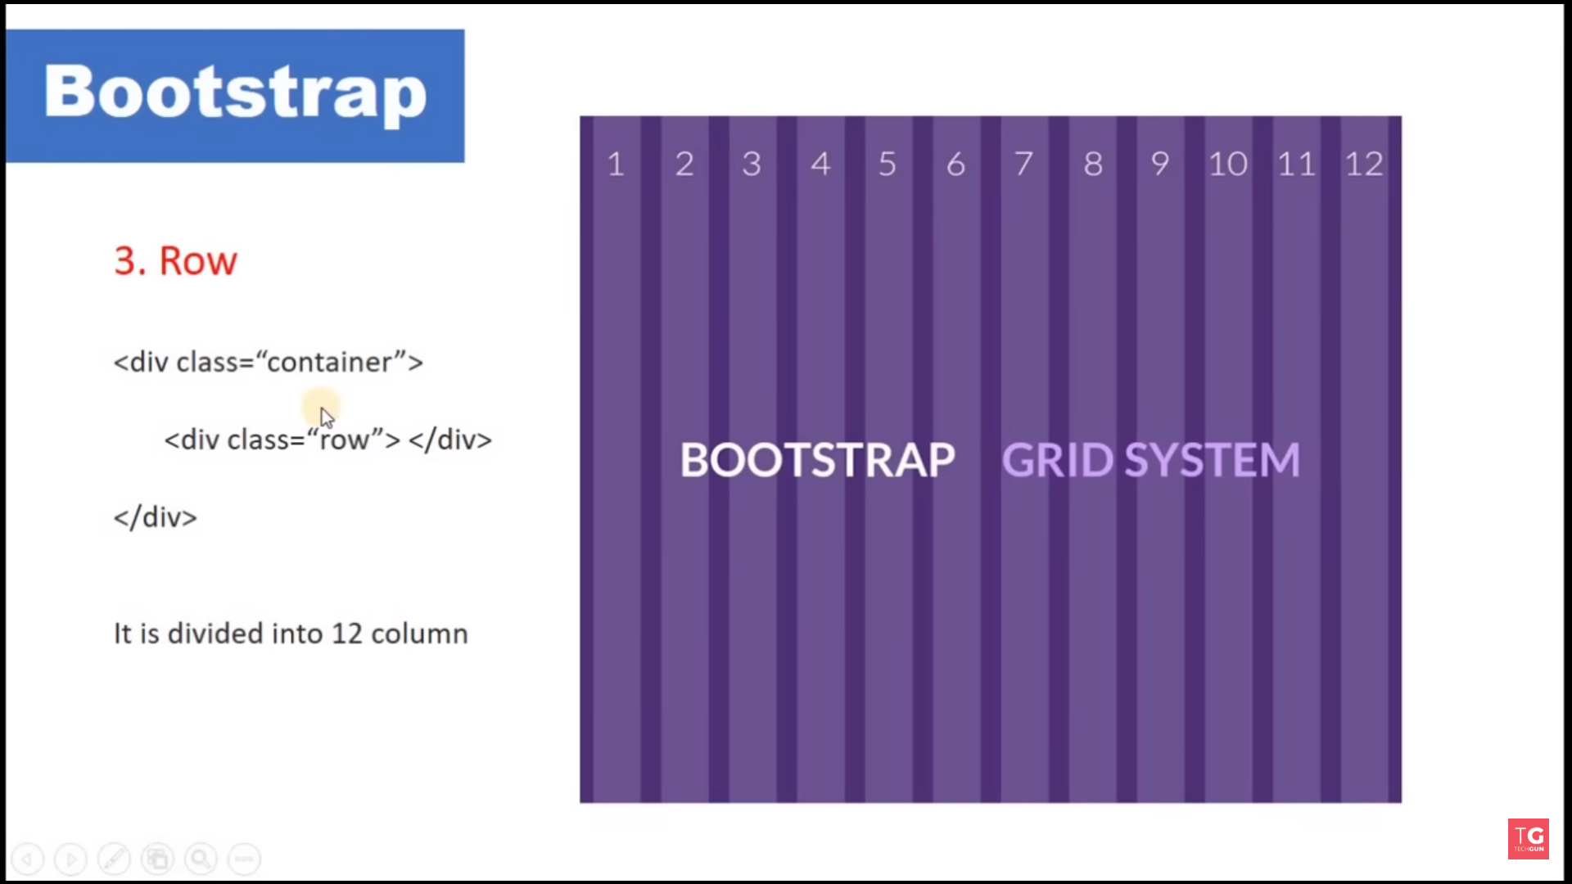

Let suppose in a page you want to make 2 grrids/column of 6 the you use like   
Container -> Row/makes 12coluns -> col-6/devides the screen into 6 by 6 of 2 grids but what if you want to make the more 2 grids of 2nd col-6 grid then you need to make another row class and then add column class like   
row/makes 12 grids inside the 2 col-6 -> col-8 col-4  
row -> col-8 col-4

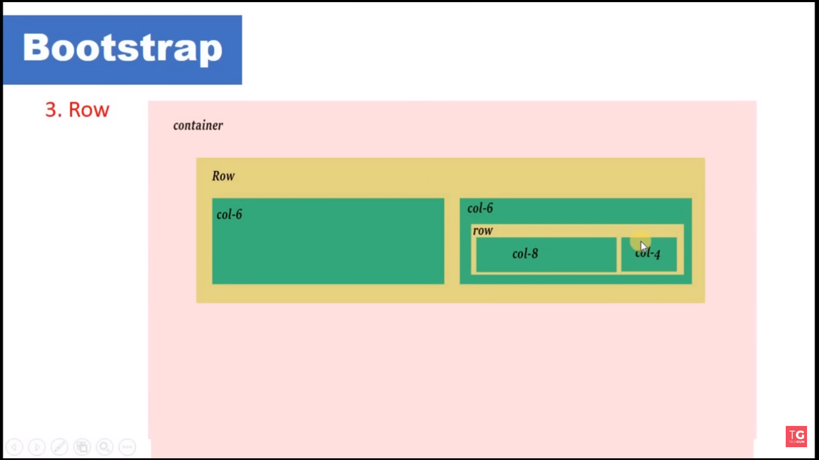

**Column/Grid**Columns are also called Grid. Columns are inside the row columns cannot be the child of another column column should be the child of row

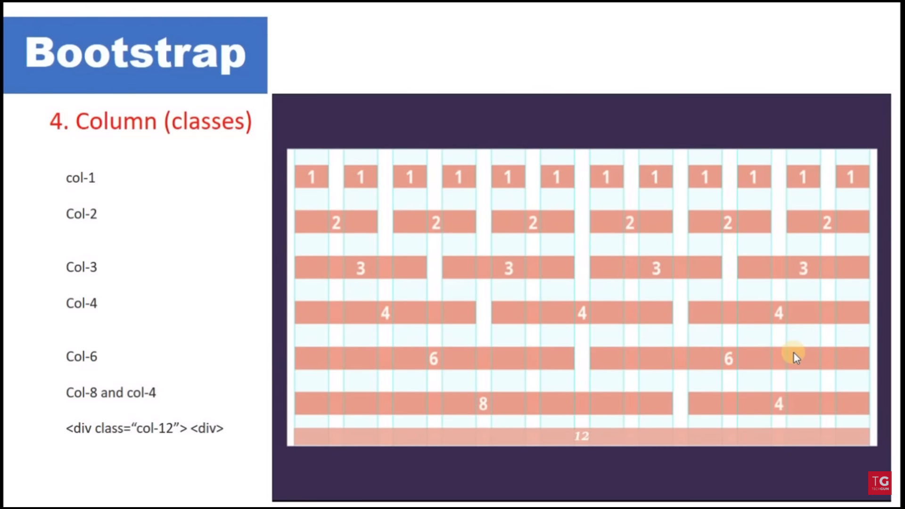

**There are 3 types of containers  
1. container-fluid**

**Container-fluid class occupy the 100% width of the screen whatever it is the screen of mobile or a desktop**

**2.container**

**Gives the blank space to the both sides of the screen and in mobile it occupy 100%   
  
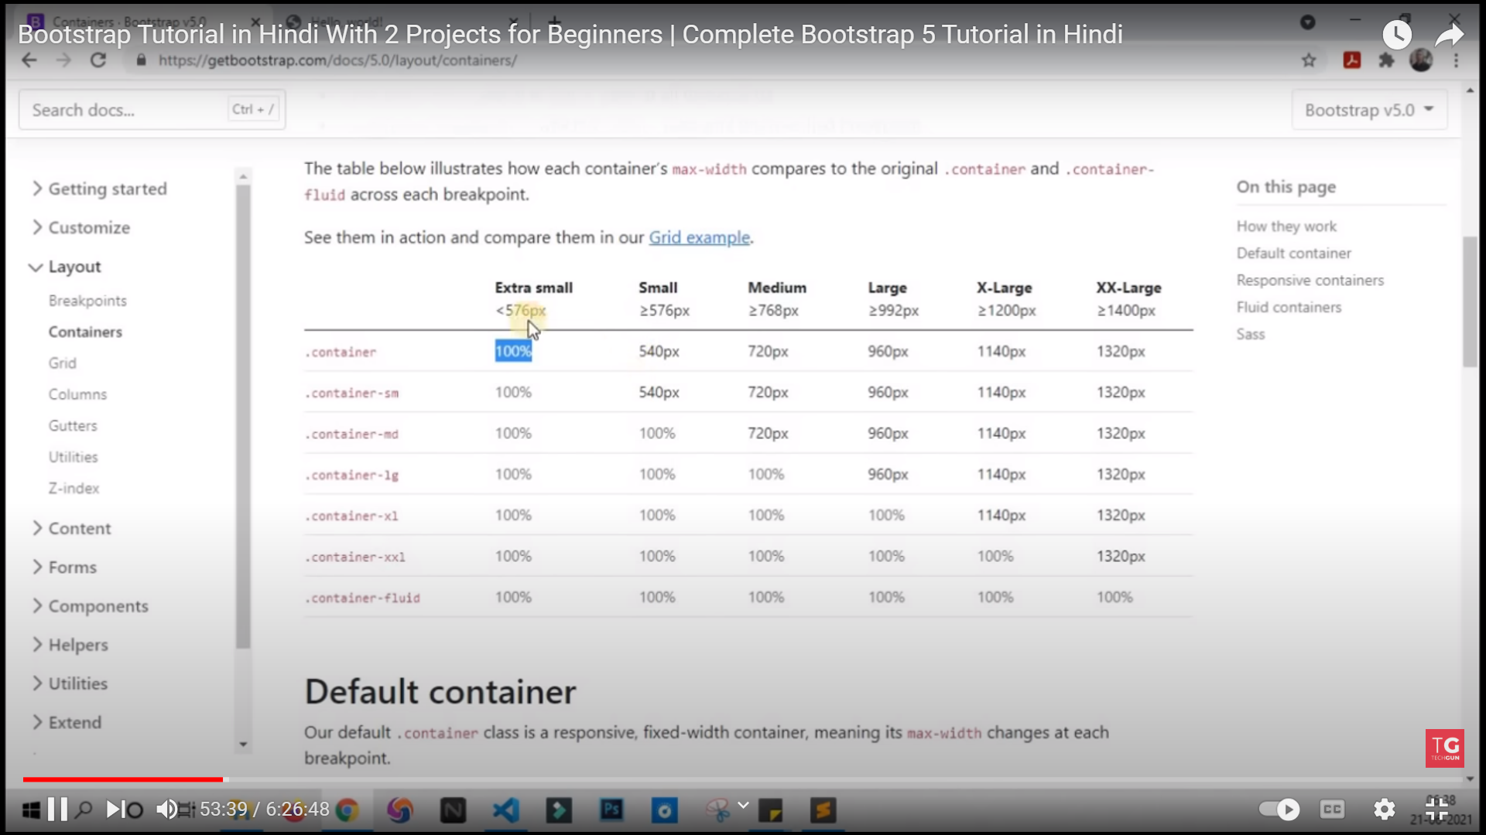**

**3. container-{breakpoint}**

**Container-lg  
container-xl  
container-xxl  
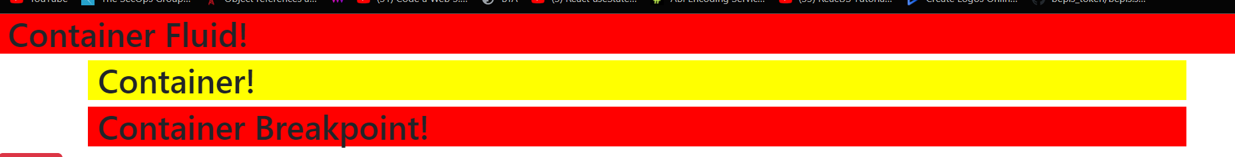**

**Bootstrap says every content should be in the column not In the row  
  
Row can be inside the Container and inside the column  
and column only inside the row   
column cannot be inside the another column**

**Bootstrap Flow :-  
Container -> Row -> Column -> Content (text,image,h1)**

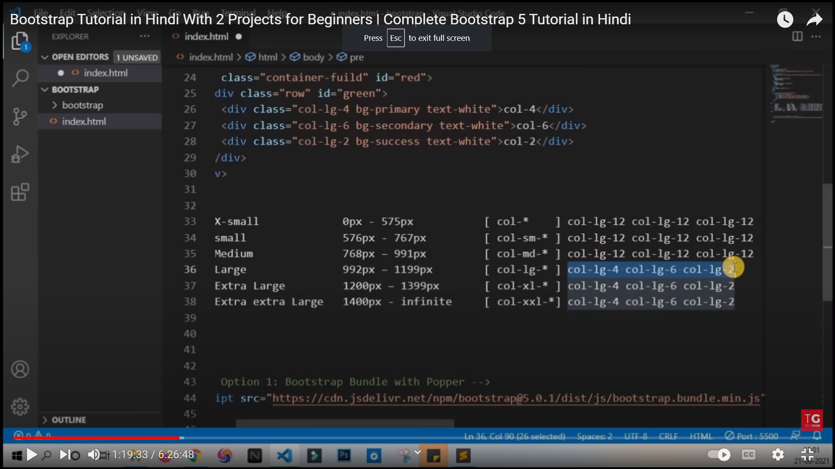

**Let suppose we define the grid for large screen after that screens which are bigger than that particular screen automatically adopt that grid setting but screens which are lower than the defined screens will be converted into full 12 columns   
  
we define grids for large screen like   
Large screen = col-lg-4 col-lg-6-col-lg-2 defined  
but screens bigger than large screen also adopt that grid settings**

**Extra large = col-lg-4 col-lg-6-col-lg-2   
 Extra Extra Large = col-lg-4 col-lg-6-col-lg-2**

**But screens which are smaller than the defined screens will be converted into   
  
x-small = col-lg-12 col-lg-12-col-lg-12  
small = col-lg-12 col-lg-12-col-lg-12  
medium = col-lg-12 col-lg-12-col-lg-12 < ---------------------------   
____________________________________________________|  
 |  
 |**

**Screen is equal to 12 grids |  
now if we want to convert our content in to 3 equal parts then we write like |  
 |**

 <div class="container-fluid">

      <div class="row">

        <div class="col-lg-4 bg-primary text-white">Column 4</div>

        <div class="col-lg-4 bg-danger text-white">column 4</div>

        <div class="col-lg-4 bg-secondary text-white">column 4</div>

      </div>

    </div>

**|  
as you can see column is inside the row and row is inside the container-fluid |  
 |  
by using this code this will happen as we discussed already----------------------------------------|**

**But what if we want same for large screen but when it goes to extra large screen then it will convert into something like other grid layout then we will write it like**

<div class="col-lg-6 col-xl-4 ">Column 4</div>

<div class="col-lg-4 col-xl-4 ">column 4</div>

<div class="col-lg-2 ">column 4</div>

**when it is in large screen then it will 6,4,2  
but when it goes to extra large screen then it will converted in to 4,4,2  
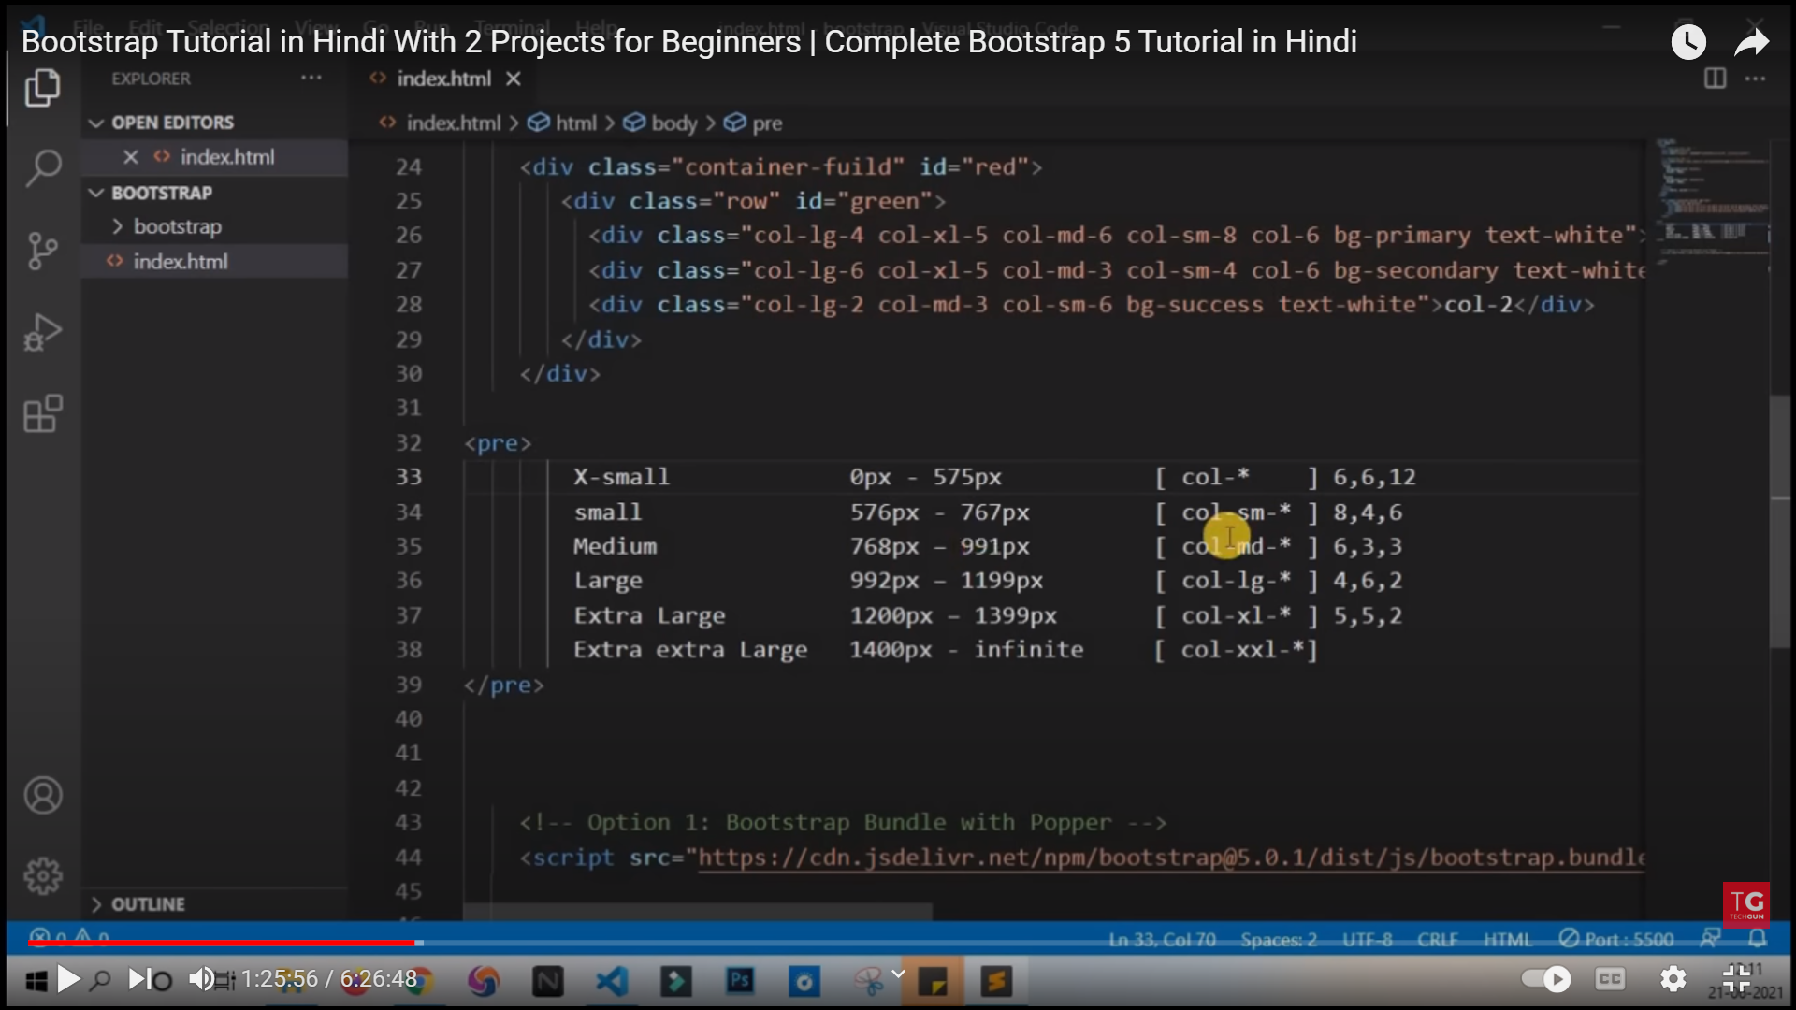**

**Nested Grids**

    <div class="container-fluid">

      <div class="row">

        <div class="col-lg-4 bg-primary text-white">Column 4</div>

        <div class="col-lg-8 bg-danger text-white">column 4

          <div class="row">

            <div class="col-lg-4 bg-success">div 1</div>

            <div class="col-lg-4 bg-warning">div 2</div>

            <div class="col-lg-4 bg-info">div 3</div>

          </div>

        </div>

      </div>

    </div>

**breaking down the grids into more grids  
  
Boostrap 4 and Bootstrap 5 provide us the shortcuts like if we want to make equal grids then we will write it like   
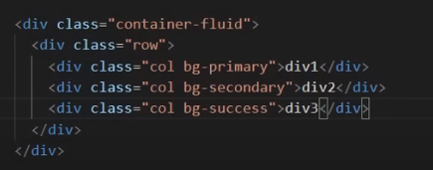  
  
we don’t need to specify the size and also this grid layout is same for all sizes and it will not change   
  
if we want to set 2 grids for same and 1 grid of the fixed size then we will write it like   
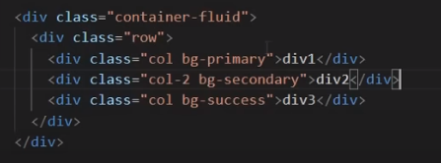  
if we want grid occupy the text space then we will write like col-auto   
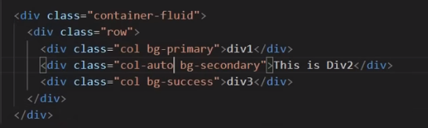  
  
if we want to specify that each row should have 2 equal grids then we will specify it with the row class like   
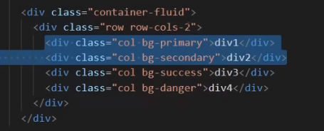  
after that it will convert into 2 rows with 4 equal grids  
  
if we want it occupy only the text space then we will write it like  
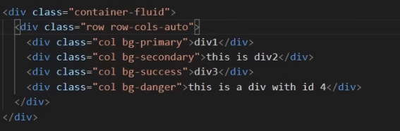  
  
if we want to give the height to the all columns then we will write it like   
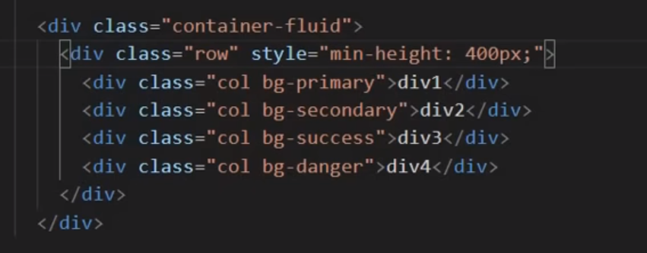  
  
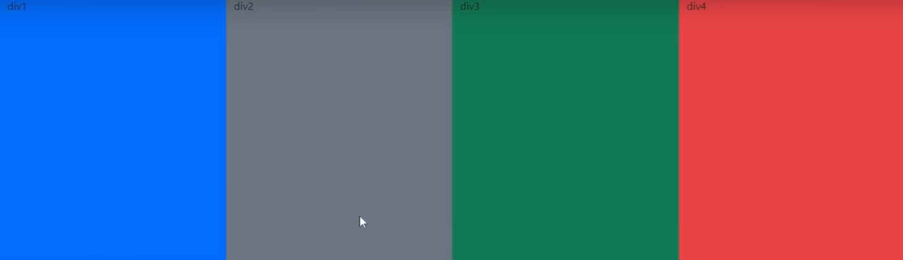  
  
and If we want height not effect on the grids and the grids are equal to the content height  
and it we show on the top then we will write it like  
  
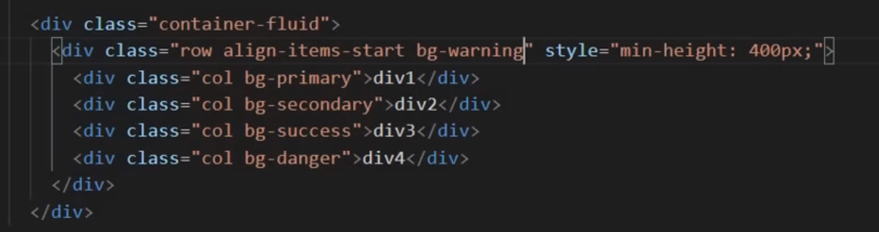  
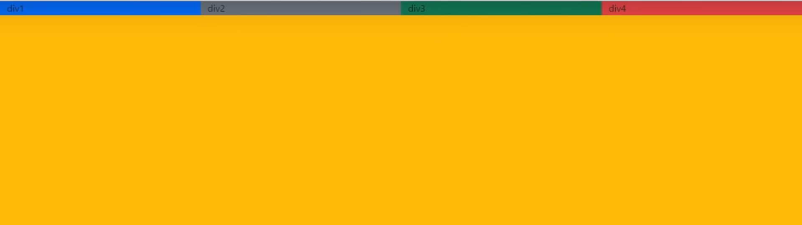  
if we want to show to the end then write it like  
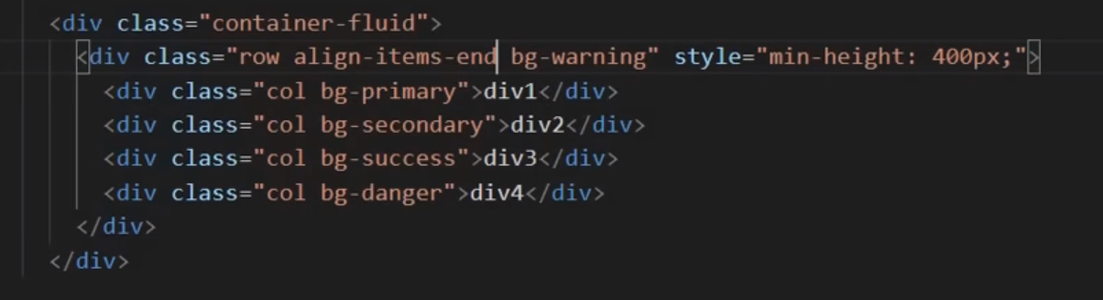  
  
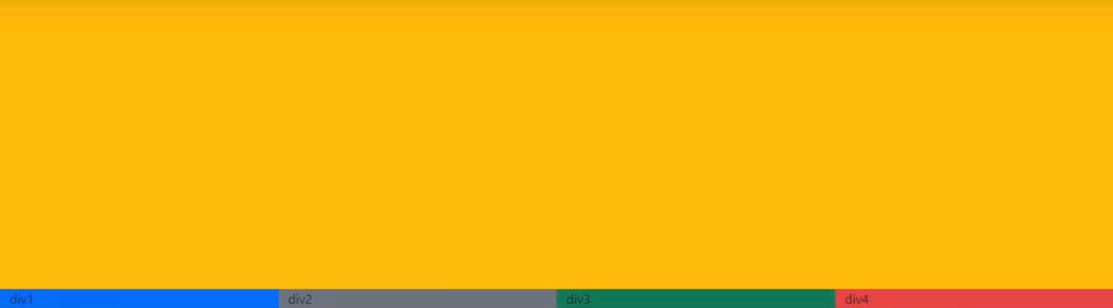  
  
and if we want to show it in the center then write it like   
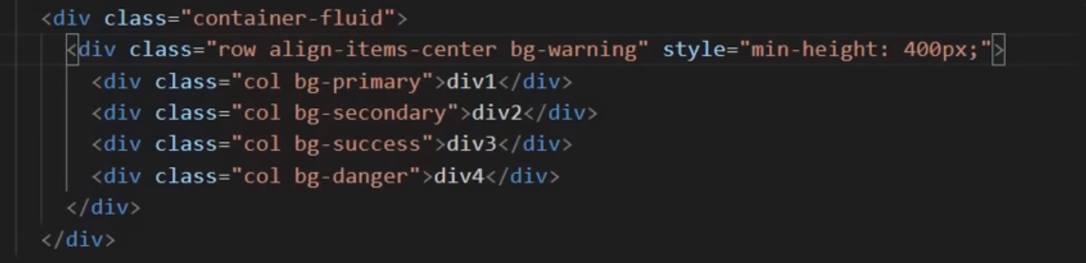  
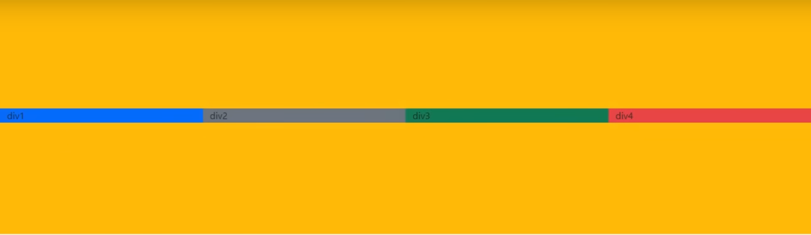  
  
if we wan to change positions of each grid then we will write it like  
  
  
